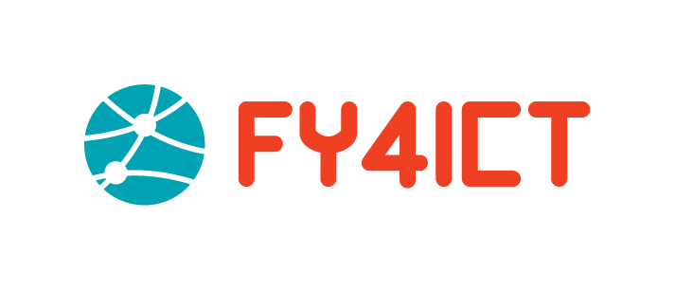
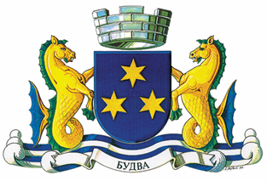
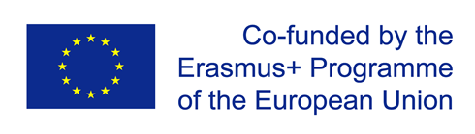

Summer school in Slovenia
How to become successful Women Entrepreneur in Europe?

Dear candidates, thank you for your interest in "How to become successful Women Entrepreneur in Europe?" summer school which will be held in Slovenia in the period from July 10th untill July 20th. The workshop is organized through the project "Supporting Female Youth from BiH and MNE in Entrepreneurship, Employment and Leadership in ICT" (FY4ICT) funded through the Erasmus + program. Applications are open until June 20th, 23:59. The form needs to be filled up in English. After the closing of the application, a selection process will be conducted and the selected candidates will be informed about further steps.
Best regards Municipality of Budva
Required from 1-9
1. Name and surname

2. Date of birth

3. City (Place of living)

4. E-mail address

5. Telephone number

6. School / Faculty

7. Person with disability
Yes
No

8. Extracurricular activities

9. Motivational letter (min 1000 characters)

